Pick&Place: Getting Started

This document shall get you started on the McuOnEclipse OpenPnP machine. It is a quick and rough guide and will be enhanced and improved over time, so any feedback is more than welcome! This document will be available on GitHub/Wiki hopefully soon.

## Links and documents

* OpenPnP: <http://openpnp.org/>
* Blog: <https://mcuoneclipse.com/2018/06/26/building-a-diy-smt-pickplace-machine-with-openpnp/>
* Blog: <https://mcuoneclipse.com/2018/05/05/sneak-preview-diy-smt-pick-place-machine-with-openpnp/>
* GitHub: <https://github.com/ErichStyger/McuOpenPnP_Machine>

## Software

The following version is used: 2018-07-02. There is a newer version available, but has NOT been tested yet.

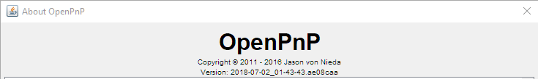

The software is available from: <http://openpnp.org/downloads/>

## USB Ports

You need two USB ports on the host. It is not possible to use two cameras on the same USB port/hub).

With the two USB cables (down camera and Smoothie board) plugged in).

You should have 3 USB ports:

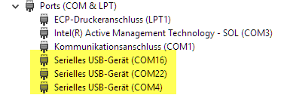

The port numbers depend on your machine.

Two ports are to the Smoothie board at 115200 baud (type ‘help’). One port will be used by OpenPnP, the other is available for a console connection in parallel.

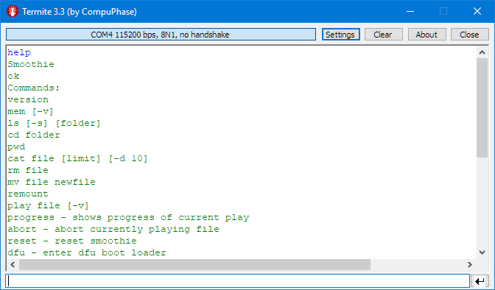

Another is the tinyK22 which is the master for the motorized feeders (38400 baud):

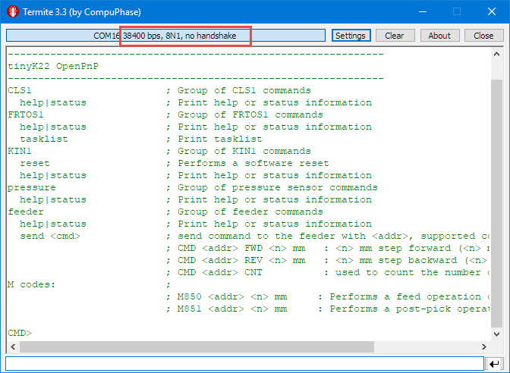

Remember your port numbers.

With both USB cables plugged in, two cameras shall show up:

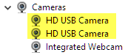

## Machine Configuration

Start OpenPnP, then go to the Scripts Directory:

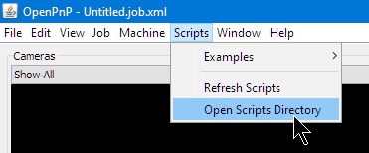

Go one directory up:

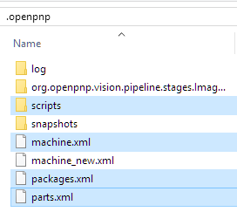

Exit OpenPnP (important, otherwise your files copied below might be overwritten, as OpenPnP updates the files on exit).

Replace the files with the ones from GitHub:

<https://github.com/ErichStyger/McuOpenPnP_Machine/tree/master/OpenPnP>

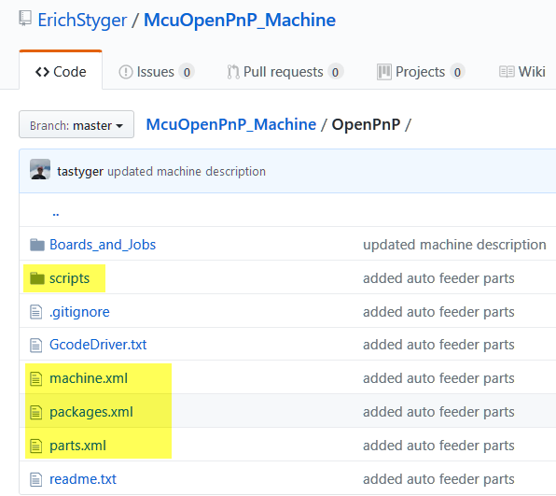

## Machine Setup (Ports)

Use the port to the Smoothie for the GcodeDriver:

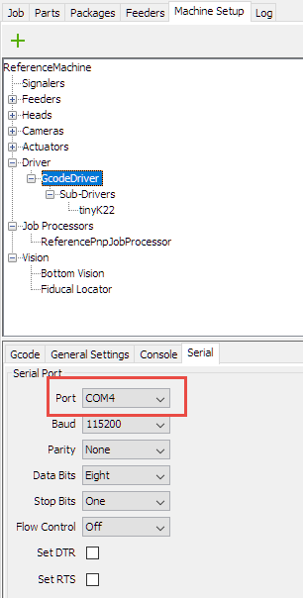

Use the port to the tinyK22 (motorized feeder):

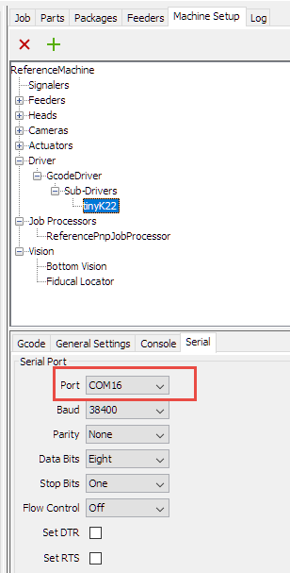

Camera is a bit tricky, as they show up with the same name. You might have to use the ‘first’ and the ‘second’ driver.

Head Camera:

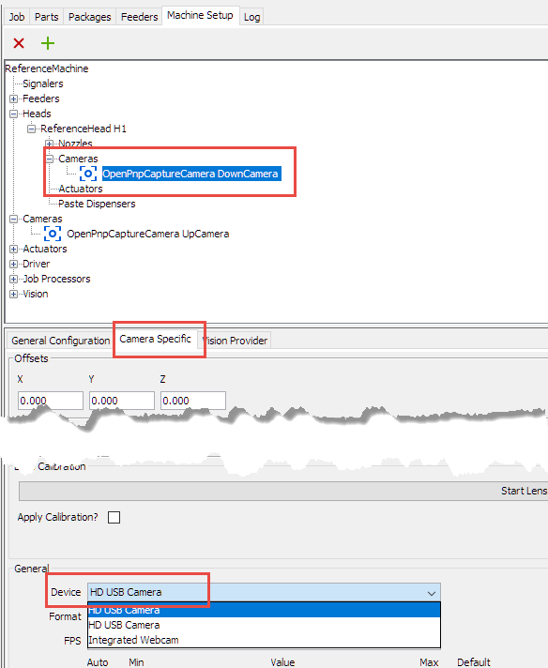

Up Camera:

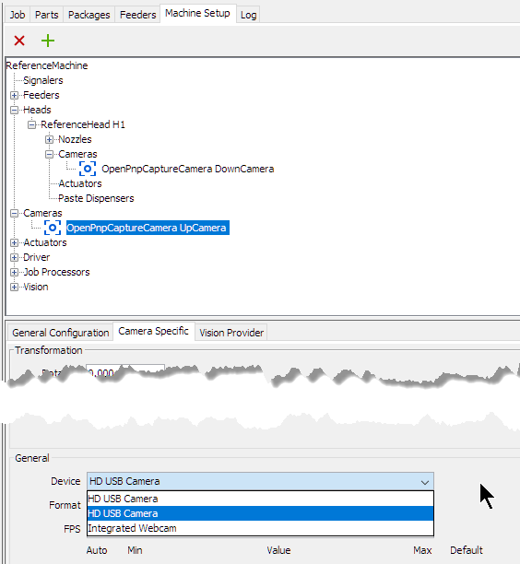

Don’t forget to use the ‘Apply’ Button!

## Starting the Machine

1. Move the head to the origin (left upper corner) with both heads in the middle position (we don’t want a head crash later on)
2. First power the machine with the switch on the back of the power supply. The LCD display shows the X, Y and Z positions
3. Plug in the USB cables (otherwise the display might not show up properly)
4. Start OpenPnP Software

## Machine Alignment

The X axis is driven by two stepper motors and need to be properly aligned.

Make sure the motors are not turned on in the machine.

Move the head to the left:

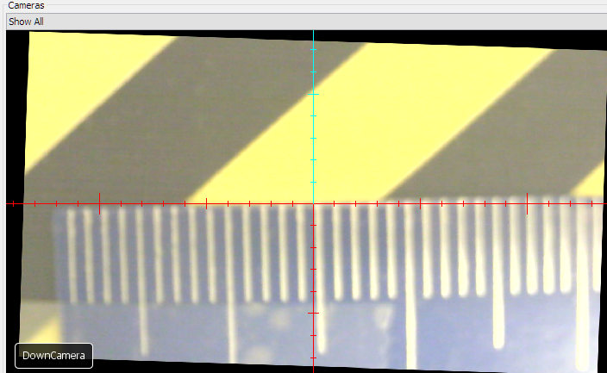

The move the head to the right. With the left belt fixed, move the right belt to have it correctly aligned. You might need to repeat that step once more.

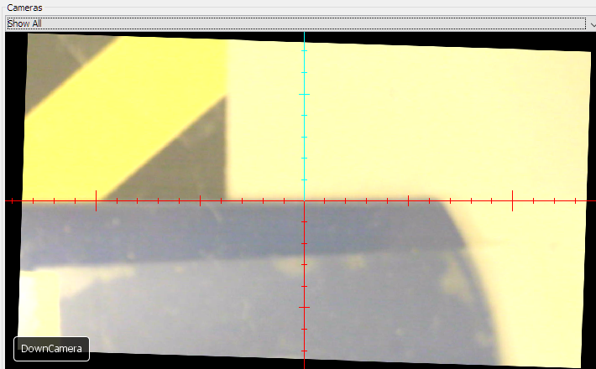

Move the head to the origin (top left) position and then turn it on.

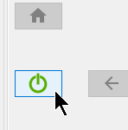

Do a Homing:

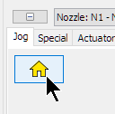

If the home position is not in the center, repeat the homing.

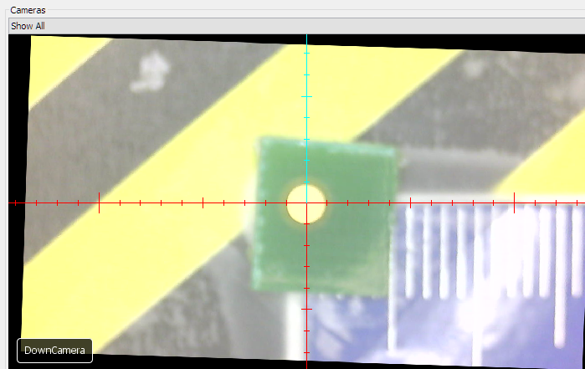

Do a Jogging to verify alignment:

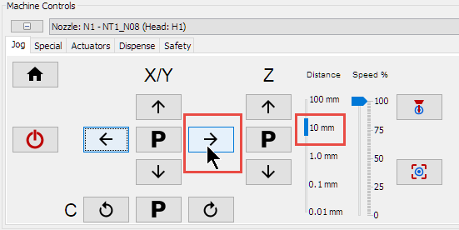

If it is not perfectly aligned, turn off the machine and repeat.

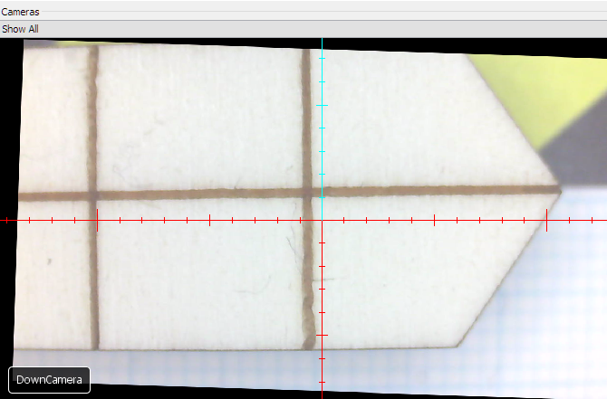

## Nozzle-Camera Offset

If needed, the offset between nozzles and camera needs to be adjusted:

1. Mark the Nozzle position (e.g. using a piece of clay)
2. Click in the position field to zero it:  
   
3. Move the camera to that marker and use the offset for the nozzle

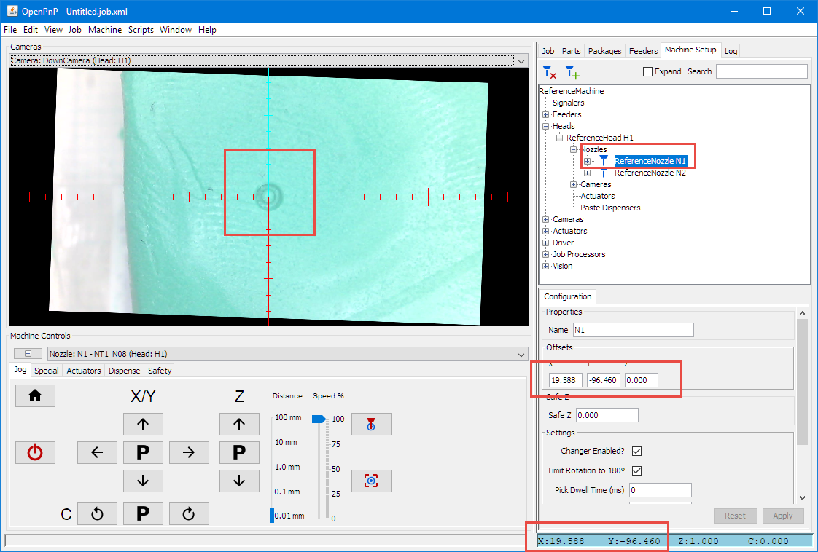

## Down Camera Position

Center both tools over the up-looking camera. They shall be centered, otherwise update camera position:

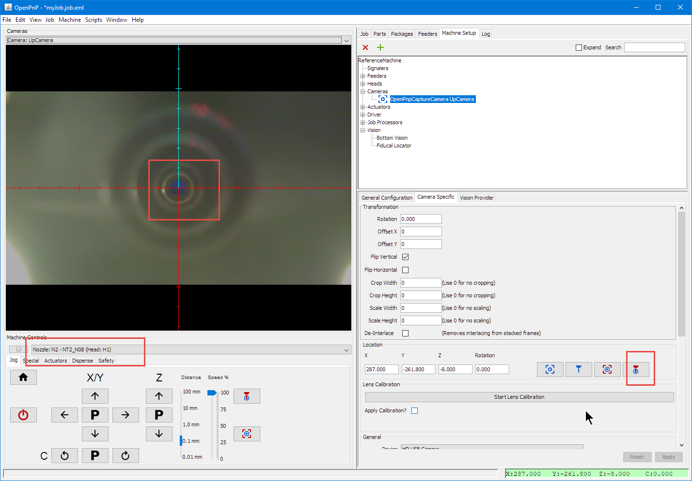

## Controls

The Jogging/Park (P) controls are for a given Camera or Nozzle (be careful not to do a head crash!)

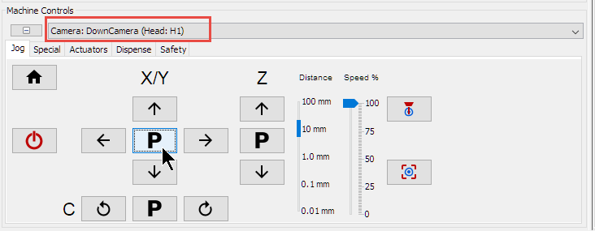

You can place the cursor with SHIFT pressed to move to a position

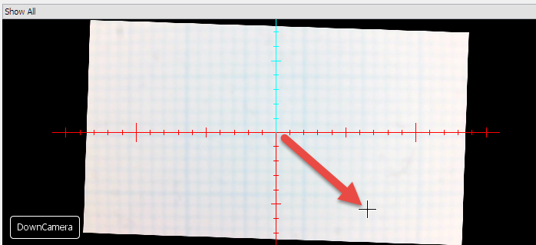

The ‘blue’ ones are used for capture a position (be careful, this can overwrite your settings!), and the red ones move the currently selected head/camera/nozzle (be careful not to produce a head crash!).



## KiCAD Placement Export

In KiCAD, export the position information:

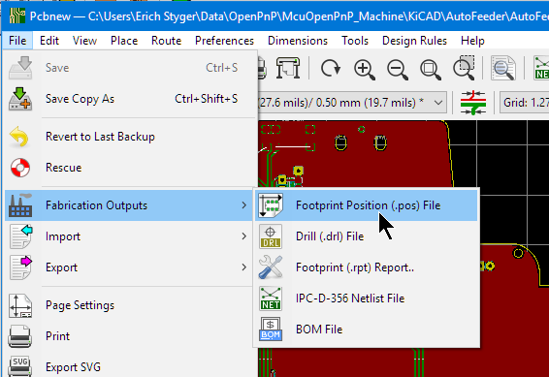

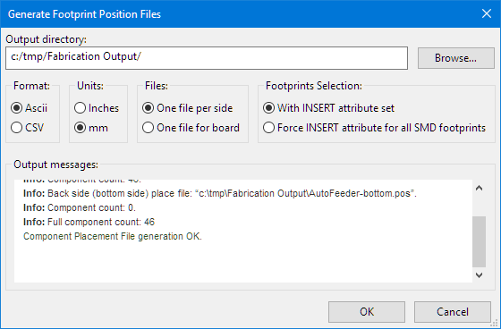

## New Job

Add new board (it will ask where to store the board settings):

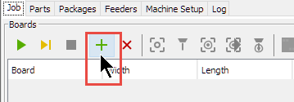

Use CTRL-S to save the job anytime.

Specify board dimensions:

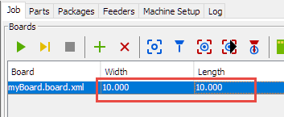

Jog with the head camera to the board (0,0) coordinate:

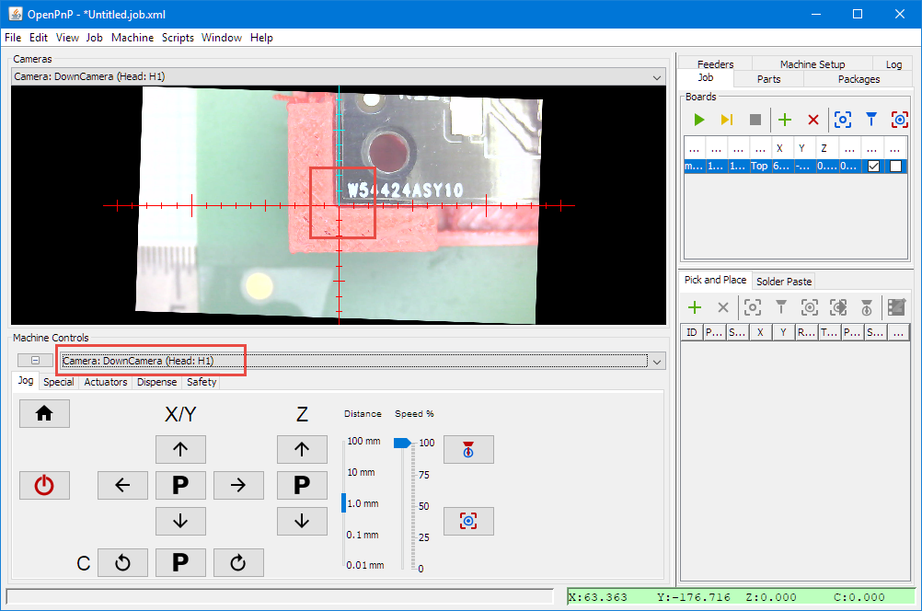

Use the button to store the coordinates:

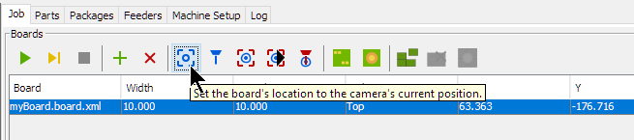

Move the Nozzle to the board origin:

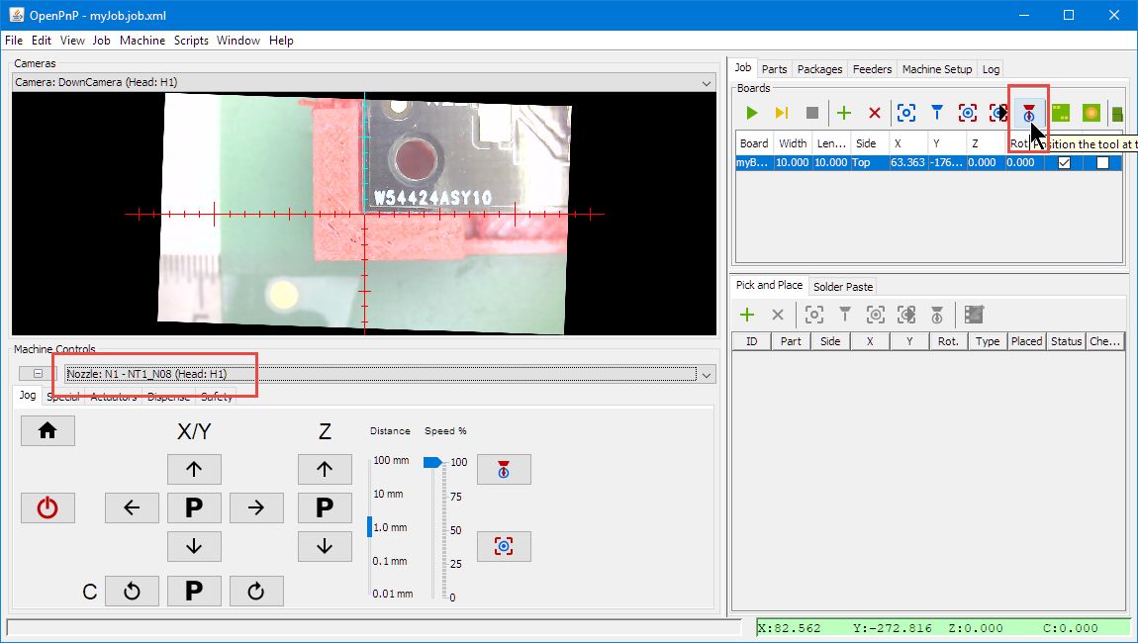

Lower the Nozzle to find the Z position of the board and enter it into the board information:

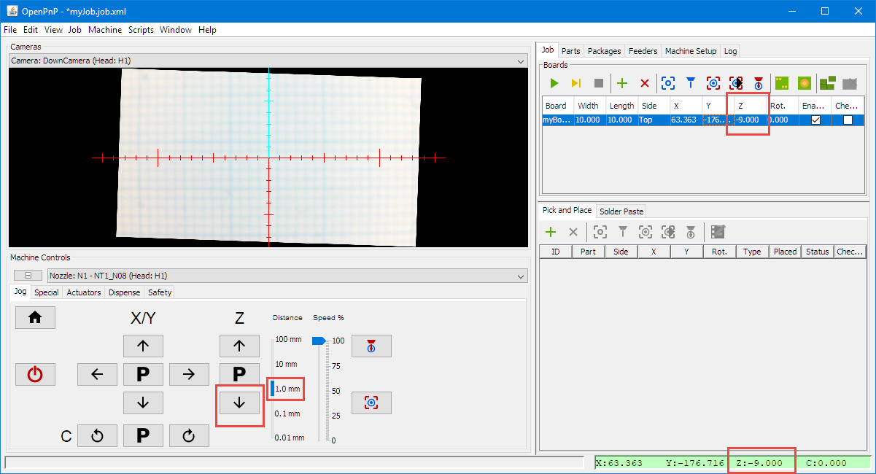

Rotation Axis of the board shall be minimal or zero:

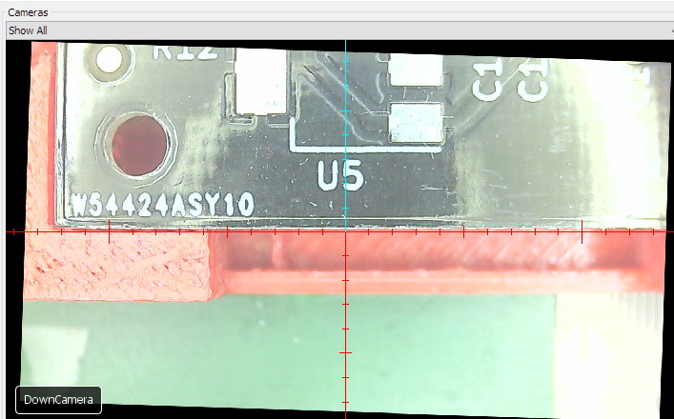

## Importing position information

Add the placement:

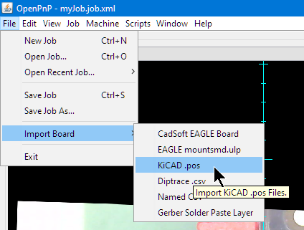

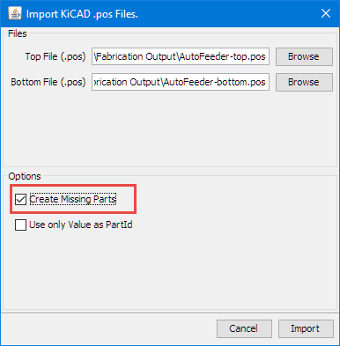

Assigning fiducials:

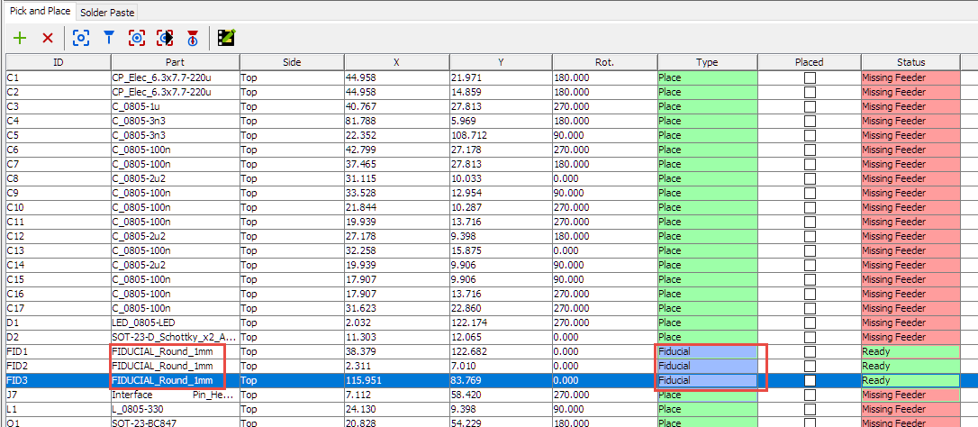

Test Fiducials (might set fiducials checks at start of job):

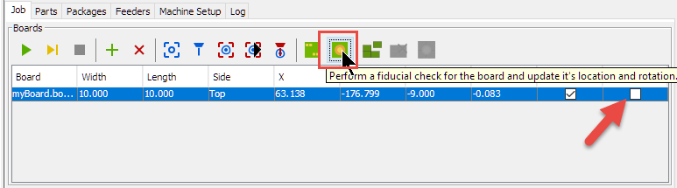

Assign Feeders or disable placing of parts.

#### Feeders

Move camera to strip feeder location:

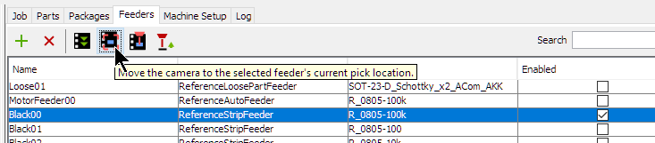

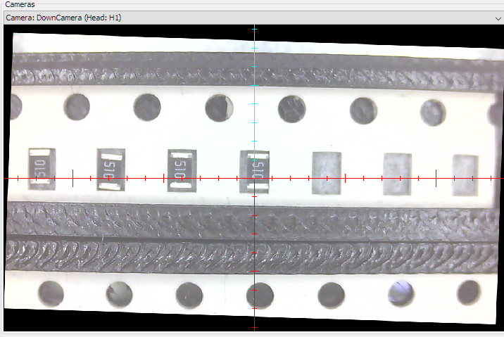

Can perform an auto-setup:

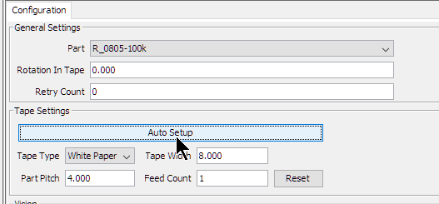

Green circles show detected holes:

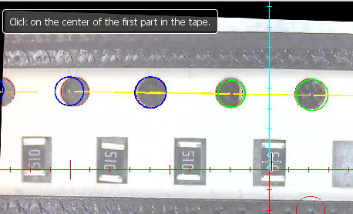

Do not forget to press ‘Apply’.

Verify part position and location with the camera:

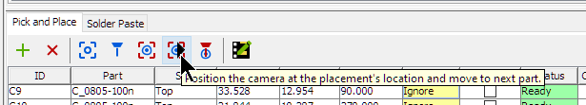

## End-Stops and Emergency Stop

In case of hitting the dnd stops or pushing the emergency stop push button:

1. Press and release emergency stop button (will unlock the Smoothie board again)
2. Make sure that the head is in a safe position
3. Home the machine again

# PCB Guidelines

#### Board origin

Board origin should be on the board (lower left corner). Below a ‘not so good’ example

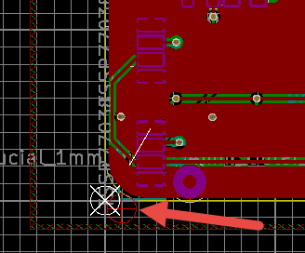

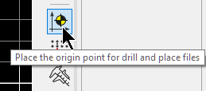

#### Fiducials

Place multiple Fiducials on the board (at least 2, better 3 or 4), at least one on the left border and one on the right boarder. Recommended is a 1 mm round fiducial. Do not place it near other similar footprints to make it easier for the visual system. If placing more than 2 fiducials, do not place them in a perpendicular way.

#### SOT-23 Loose Parts

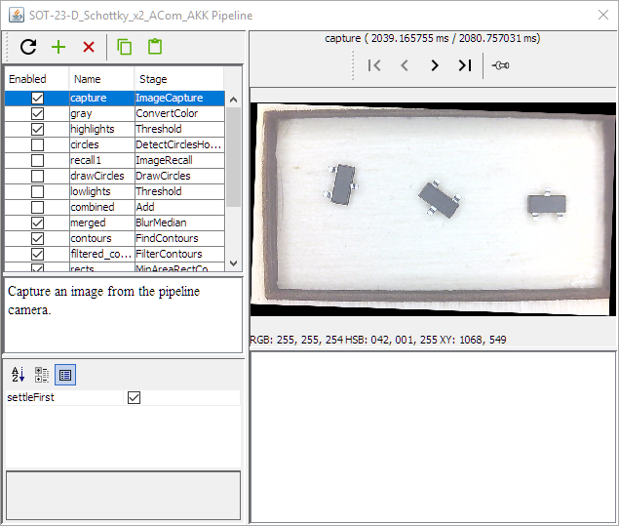

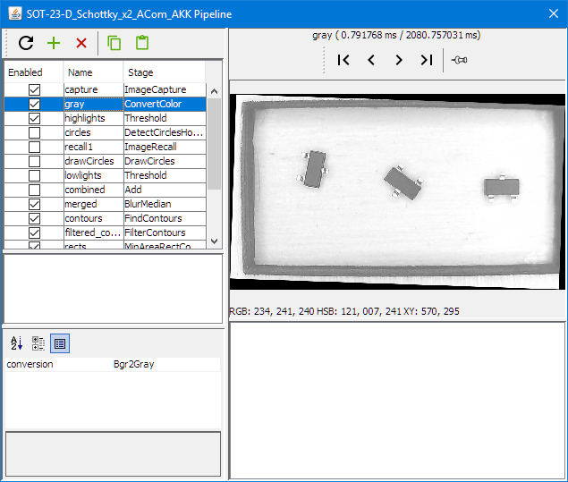

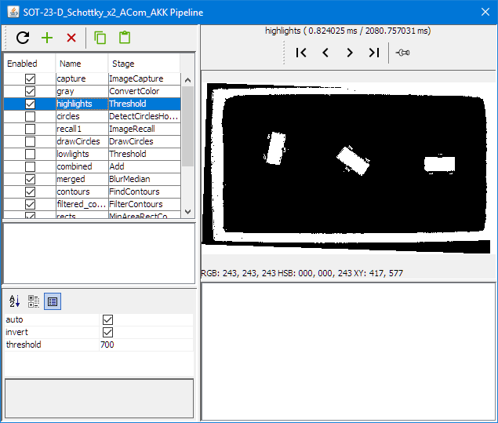

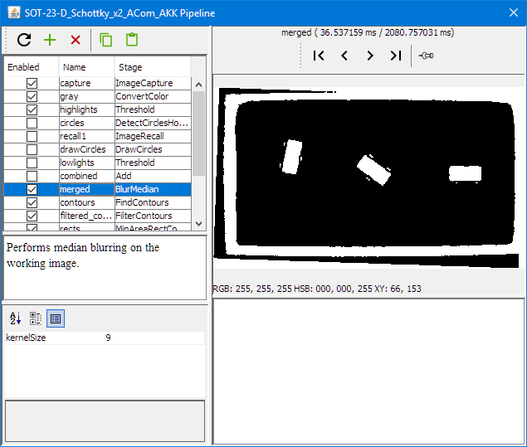

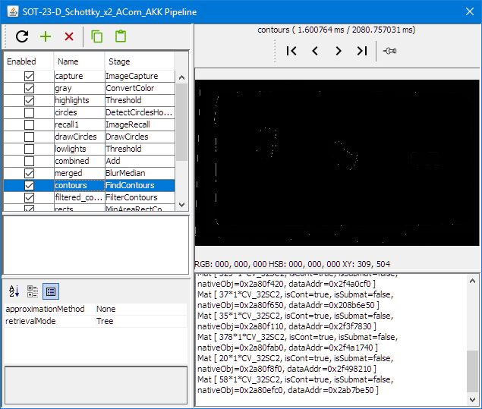

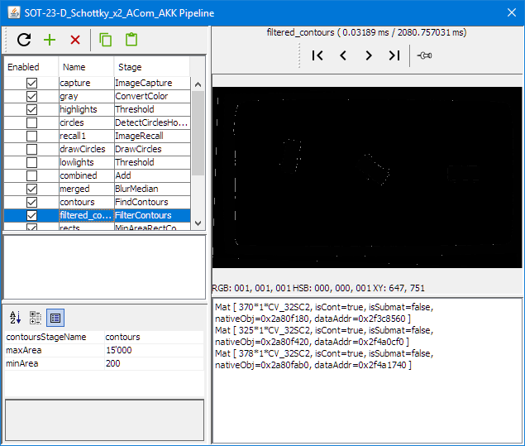

Resistor

